

Suggested answers only

|  |  |  |
| --- | --- | --- |
| Rewrite the following sentence to show feelings with actions:  ***The girl was scared.*** | | |
| **Step 1:** List *actions* when someone was ***scared***. |  | **Step 2:** Write sentences based on what you have brainstormed in Step 1. |
| *E.g. body felt numb/legs turned to jelly* | E.g. *The girl’s body felt numb. Her* |
| * *stomach clenched* | *legs turned to jelly.* |
| * *throat tightened* | 1. *She cringed with a tightened* |
| * *cringed* | *throat.* |
| * *froze* | 2. *She stood frozen to the spot.* |
| * *let out a silent scream* | *She let out a silent scream.* |

***Your turn!***



|  |
| --- |
| In the example, the emotion of being “excited” is depicted with actions. The ways the heart beat and “I” laughed are vividly described to allow the reader toimagine or even to experience what the character feels. |

***How?***

***Showing***

|  |
| --- |
| ***Telling*** |
| Directly give information with limited room for imagination | Paint a picture in readers’ mind |
| *I was excited about the news.* | *When I heard the news, my heart started pounding. I couldn’t help letting out a scream.* |

***Showing***

***Telling***

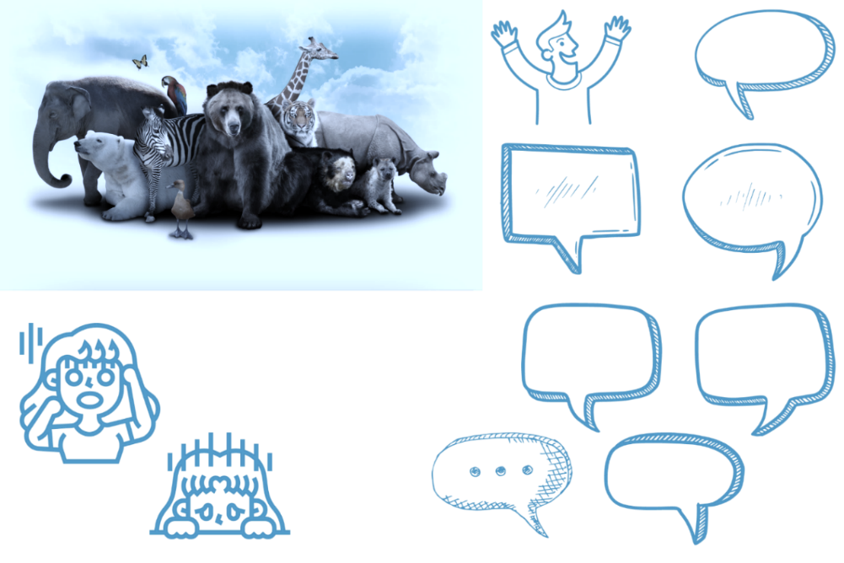







**To show feelings:**

Describe characters’ ***actions*** in that emotion.

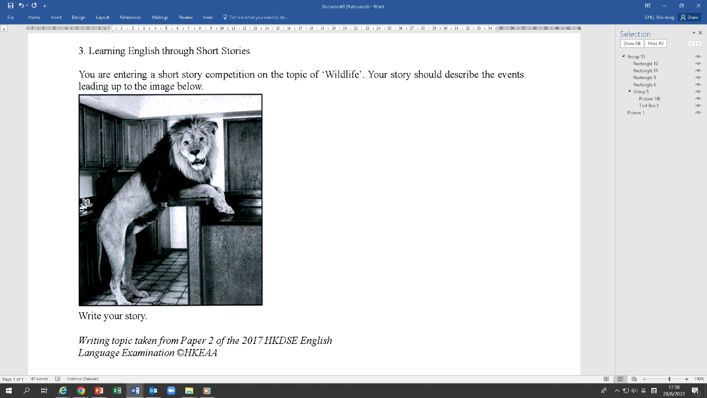

Curriculum Development Institute

Education Bureau HKSAR ©2022

*I heard some noise from the kitchen so I (e.g.) went over nervously. When I walked into the kitchen, I saw (a) a hungry and angry lion. (b) I was shocked and frightened. The lion heard me and turned around. It crawled towards me with its tail held high. (c) I was afraid until it lay in front of me, purring like my pet cat. Seeing its gentle gesture, (d) I felt rather relieved. All of a sudden, the lion (e) said sadly, “I’m starving.”*

|  |
| --- |
| *I heard some noise from the kitchen so I (e.g.) gulped and tiptoed over to the kitchen* |
| *with butterflies in my stomach. When I walked into the kitchen, I saw a lion (a) scratching* |
| *the counter top of the bar table fiercely with its belly growling. (b) My jaw dropped and* |
| *my heart leapt into my throat. The lion heard me and turned around. It crawled towards* |
| *me with its tail held high. (c) I trembled inside, sweated profusely and was glued to the* |
| *spot until it lay in front of me, purring like my pet cat. Seeing its gentle gesture, (d) I* |
| *lowered my guard and leaned forward. All of a sudden, the lion (e) whimpered with a long* |
| *face, “I’m starving.”* |
|  |
|  |
|  |

Rewrite the underlined parts to show feelings with *actions*:

*Notes: Prepositional phrases (e.g. with sweaty palms, tearful eyes, a trembling voice) can also be used to show feelings, especially to replace adverbs.*

***Topic***

You are entering a short story competition on the topic of ‘Wildlife’. Your story should describe the events leading up to the image below.

Write your story.

*Writing topic taken from Paper 2 of the 2017 HKDSE English Language Examination ©HKEAA*

*Notes: Actions of both the character and the character’s body parts can be described. The subject varies in different descriptions, i.e. the character or the*

*character’s body parts.*